Influence of over-size particles on the Atterberg limits of sand-clay mixtures

last compiled Tue. 2021-10-12, 11:22 AM

Table of Contents

Abstract 1

Introduction 3

Historical definitions of soil behavior thresholds 4

Oversize particle removal in plasticity tests 5

Previous research on coarse fraction influence on Atterberg limits 7

Effect of coarse fraction particle size 7

Effect of coarse fraction particle shape 8

Effect of coarse fraction’s particle-size uniformity 8

Objectives 9

Materials and methods 9

Experiment 1 mixture components 9

Experiment 2 mixture components 11

Experiment 3 mixture components 11

Component characterization 12

Mixtures and Atterberg limit tests 13

Results and discussion 14

Experiment 1 14

Experiment 2 19

Experiment 3 19

Conclusions 21

References 22

# Abstract

Sand-clay mixtures are commonly manufactured for use on baseball and softball infield skin surfaces.

Infield mixes may contain a range of sand particle sizes. Standard protocols for the Atterberg limit tests mandate that sand >425 μm are removed from the test specimen via washing. This directive makes it difficult to compare mixes, because the effect of the fines’ plasticity may be confounded by removing different amounts of sand.

Three experiments were conducted to re-appraise the practice of removing ‘oversize’ particles from Atterberg limit specimens.

In Experiment 1, an angular quartz sand was fractionated to five individual mesh sizes (2.0-1.0, 1.0-0.5, 0.5-0.25, 0.25-0.15, and 0.15-0.05 mm). Each sand size was mixed with a kaolinitic clay at 0, 20, 40, 60, 70, 75, and 80 percent sand by mass.

At low sand contents, liquid limit (LL) and plastic limit (PL) showed a linear decrease per unit sand addition. This suggests the sand grains are fully suspended in the clay-water matrix and do not participate in the soil’s behavior. The linear relationship deteriorated above 50% sand for LL and above 30% sand for PL. Mixes containing coarser sands adhered more closely to a linear relation than finer sands. It is postulated that as the soil thread dries, a greater number of particle contacts among the finer sand grains encourages defects and micro-cracks to propagate through the soil thread.

Experiment 2 compared the effect of mixing either an angular or a round sand with kaolinitic clay. Each sand contained particles only 0.5-1.0 mm. Little difference was observed in the LL and PL, suggesting sand particle shape plays a minimal role in these tests.

Experiment 3 compared the effect of sand size uniformity on LL and PL. Two sands with C~~u~~ values of 1.9 and 3.9 were mixed with an illitic clay at sand contents from 0-80%. The high-C~~u~~ sand had higher LL and PL for equivalent sand contents. The increase in water content was roughly equal (~1 %) for both tests, so little change in plasticity index occured.

Results from this research suggest particles with sieve diameter 2000-425 μm need not be removed for Atterberg limit tests. The effects of particle shape and particle-size uniformity are small compared with that of particle size. These findings can encourage more useful evaluations of infield mixes with intermediate sand content, and to expedite the test procedures.

# Introduction

Much of a baseball game is played on a small, un-vegetated portion of the field termed the “infield skin,” or simply the “infield.” This area comprises <10% of the playing surface, but it is intensively maintained because of its importance to gameplay.s The soil on this area should exhibit a stiff but plastic soil consistency during competition.

A general definition of ‘plastic’ is the capacity to undergo non-reversible deformation by an applied stress (Worrall, 1986). On an infield, a plastic soil tends to deform around the players’ cleats without cracking or chipping. Figure 1 demonstrates that in this state, surface disruption is limited to a small indentation matching the shape of the cleats. These small indentations are unlikely to alter ball response. As the soil dries, it becomes increasingly brittle and the cleats induce a more brittle failure mechanism in which larger chips and clods are formed. If a batted ball strikes one of these larger imperfections, an unpredictable change in ball path may induce fielding errors and player injuries.

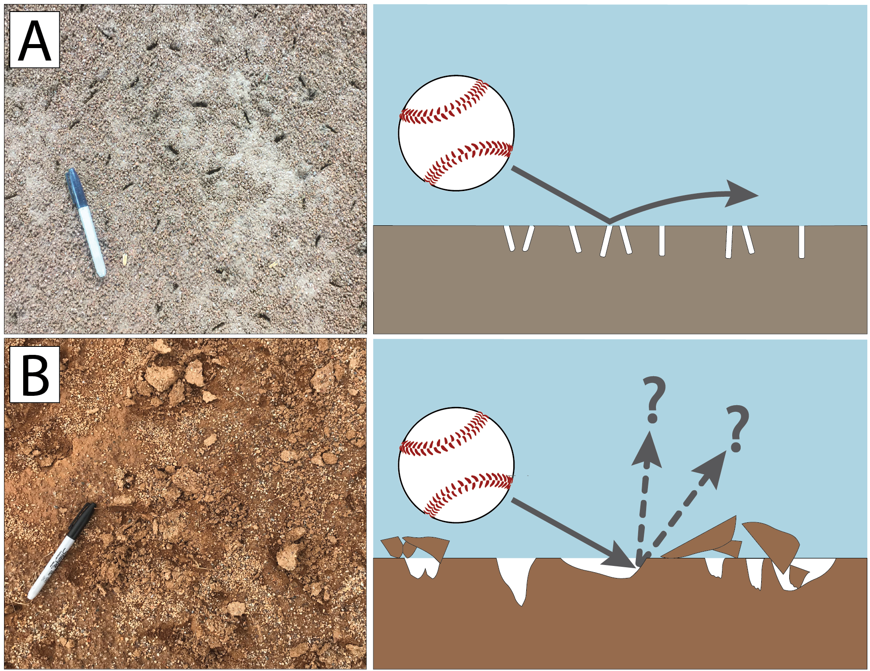

Figure 1: **A.** The “cleat-in/cleat-out” effect ensures predictable ball response. **B.** Cleat indentations and soil clods inhibit a smooth and predictable ball path.

Laboratory tests for soil plasticity help predict how a given soil will respond to changes in water content. Therefore, these tests may may be useful for predicting how a given infield soil will behave as it wets or dries.

The remainder of this section describes the historical background of soil plasticity, their potential utility and shortcomings when applied to infield soils, and prior research on the effect of coarse particles on soil plasticity.

## Historical definitions of soil behavior thresholds

A. Atterberg was among the first to describe the water contents marking identifiable changes in soil behavior (Atterberg, 1911; 1974). He outlined seven characteristic water contents whose values were unique for every soil. These water contents marked characteristic changes in behavior (behavioral thresholds). From wet to dry, the thresholds comprised: (1) upper limit of dense liquid, (2) limit of water-hardness, (3) lower limit of dense liquid (flow limit), (4) adhesion limit, (5) plastic limit, (6) cohesion limit, and (7) shrinkage limit. Today, four principal states of soil are commonly recognized: solid, semi-solid, plastic, and liquid. These are separated by the shrinkage, plastic, and liquid limits (McBride, 2002).

Atterberg also described test methods to quantitatively identify his thresholds. The flow limit (i.e. liquid limit) was measured by first mixing a soil to a paste-like consistency in a bowl. A groove was cut in the sample and the bowl was agitated against the palm. Dry soil was added until the groove barely closed after several blows. The water content of the sample was then taken and considered the liquid limit. The plastic limit was determined by repeatedly rolling the soil into thin threads. When the sample could no longer be rolled out, its water content was determined and taken to be the plastic limit. The difference between the LL and PL the “plasticity number” (today known as plasticity index or PI). The PI represents the range of water content over which the soil is plastic.

Atterberg’s original methods were modified and standardized by geotechnical engineers (Terzaghi, 1925; Casagrande, 1932). The liquid limit test is now performed with a mechanical device comprising a brass cup agitated by a rotating cam. A standardized grooving tool ensures the soil paste is shaped equally. Terzaghi (1925) introduced the use of a fixed thread diameter (3.2 mm or 1/8 in) for the PL test. Otherwise, the PL test remains unchanged.

## Oversize particle removal in plasticity tests

The role played by the coarse fraction on LL, PL, and PI has received less attention than that of clay mineralogy. Researchers have focused more on the fine fraction because the tests are designed to characterize the fines. However, the size and shape of coarser particles also affect the soil’s plasticity.

Casagrande (1932) stated that Atterberg’s tests should be performed only on material <425 μm sieve diameter. He suggested the coarse fraction must be removed from the sample because large grains could affect the groove closure in the brass cup or interfere with the rolling of a thin soil thread. The authors are unaware of any published rationale for the choice of 425 μm diameter as a maximum allowable particle size. Casagrande probably deemed it impractical to wash the entire sample through a finer sieve and arrived at this diameter as a suitable (if arbitrary) compromise. The 425 μm sieve diameter would have been a convenient choice because it also formed the boundary between ‘fine’ and ‘medium’ sand in Casagrande’s Airfield Classification (AC) (Casagrande, 1947)[1].

Modern Atterberg limit protocols mandate that if particles > 425 μm cannot be removed by hand, the sample must be wet-sieved [ASTM International (2018); AASHTO (2020);]. This process often yields several hundred mL of water for ~150 g of soil solids. The sample’s water content must then be reduced to the LL. Slow drying is the preferred method because filtration may remove soluble salts which may influence the test result.

If the sample is wet-sieved, its LL must be corrected for the mass of removed particles. It is assumed that all water associates with the fines and that the LL of the mix is inversely proportional to the sand content. This concept was termed the “linear law of mixtures” by Sivapullaiah and Sridharan (1985). The whole-soil liquid limit is computed from the linear law as:

$$LL_{whole-soil}=LL_{<425μm fraction}×m_{<425μm fraction} (1)$$

where $m_{<425μm fraction}$ is the mass percent passing the #40 sieve, as a decimal. The same calculation can be made for the PL. However, data from Barnes (2013) suggests these corrections may be invalid for oversize content as low as 10%.

## 

Infield soils are typically blended offsite by mixing a relatively pure sand with a finer-grained soil. The material is often screened to 2 mm but may contain as much as 50% of its total mass between 0.425 and 2 mm. Therefore, traditional Atterberg limit test methods would require much of the sample to be removed via wet sieving.

The requirement to remove “oversize” particles makes comparing test results from different infield mixes more difficult. Consider a case in which two soils have the same total sand content, but contain different sand gradations and also different clay minerals. One sample may have significantly higher LL or PL, but it will not be not clear whether the difference is due to the nature of the fines, or simply because more sand was removed.

A linear-law correction (Equation (1)) could be attempted to compute the whole-soil LL and PL. However, as mentioned above, data from Barnes (2013) suggests the linear law may be invalid for oversize content as low as 10%. Infield mixes usually contain 50-80% sand (Schroder, 2012), so the finding by Barnes (2013) suggests a linear correction is unreliable for infield mixes.

The washing procedure also increases the time needed to perform the test. In a commercial lab this increases labor costs, and in academic research it reduces the number of samples which can be tested.

## Previous research on coarse fraction influence on Atterberg limits

Artificial soil mixtures have been studied to clarify the role coarse particles play in plasticity tests. Experiments have tested the effects of particle size, particle shape, and particle size uniformity. All three parameters have been shown to affect the LL and PL of a soil. Several of these studies are next discussed.

### Effect of coarse fraction particle size

Dumbleton and West (1966) tested mixes containing sand or silt (both natural quartz and glass spheres) with either kaolinite or montmorillonite clay. For the same percent “coarse addition,” smaller glass spheres (D50 = 350 μm) caused a greater change in the LL or PL compared to larger spheres (D50 = 110 μm). Silt-sized particles caused even larger changes in LL and PL.

Sivapullaiah and Sridharan (1985) also mixed coarse particles with clays. Both the LL and PL were affected by the size of the added particles. Mixes containing coarser sand (425 μm – 150 μm) adhered more closely to the linear law of mixtures than finer sand (150 μm – 75 μm). Mixes containing added silt deviated further from the linear law.

Barnes (2013) tested mixes of London clay with two grades of sand (425-212 μm or 212-63 μm) or with silt, in 10% increments of coarse particles. All coarse additions raised the plastic limit more than predicted by the linear law. Fine sand had a greater effect than coarser sand and the effect of silt was greater than either sand gradation.

Rehman et al. (2020) tested natural soils (not artificial mixtures) sieved to either 2 mm or 425 μm. There was little difference in the PL and LL for soils with LL <35. When the LL exceeded 35, greater discrepancies were observed. This result is not surprising given the higher specific surface area of finer particles. The authors did not specify whether the sieving procedure was performed wet or dry.

Note that with the exception of Rehman et al. (2020), all the above studies used sand exclusively < 425 μm.

### Effect of coarse fraction particle shape

Particle shape comprises both sphericity (equality of dimensions) and roundness (roughness of particle surface).

Dumbleton and West (1966) studied the influence of the coarse fraction’s shape on Atterberg limits. Particles with irregular shapes increased the liquid and plastic limit relative to glass spheres. Increases in the LL and PL were roughly equivalent. For the same mass % coarse addition, PL increases in the plastic limit were observed in the following order: platy silt > bulky silt > angular sand > round sand. The authors postulated that platy and angular particles had higher surface area, requiring more water to coat their surfaces before they could slide or flow past one another.

Findings by Sivapullaiah and Sridharan (1985) differ from those of Dumbleton and West (1966), who observed no effect of sand particle shape on the Atterberg limits. These authors mixed either angular or round sand of the same particle size fraction (150 μm – 75 μm) with bentonite clay at sand contents ranging from 20 - 95 %. They reported no difference in the liquid or plastic limits.

### Effect of coarse fraction’s particle-size uniformity

Particle-size uniformity is the similarity of diameters among soil particles. Uniformity has been mathematically defined in various ways (Holtz et al., 2010). The coefficient of uniformity (C~~u~~) is a commonly used parameter. C~~u~~ is the ratio between the diameters at which 60% and 10% of the sample is finer:

$$C_{u}=\frac{D_{60}}{D_{10}} (2)$$

Few studies are available on the effect of sand uniformity on Atterberg limits of soil mixtures. This is likely due to the total range of particle sizes permitted in the test. When all sand >425 μm is removed, the total range of sand particle diameters differs by a factor of just 10. Efficient particle packing - defined as the ability of smaller particles to fit comfortably in the voids between larger particles - is precluded when the majority of particle diameters fall within a single order of magnitude (Lade et al., 1998).

The single study which investigated the effect of sand particle size uniformity on the Atterberg limits found few differences. Dumbleton and West (1966) reported that mixes made with less-uniform sand had similar Atterberg limits to mixes containing sand from a single mesh size. However, all of the sands in their experiment were between 53 and 425 μm, in conformance with the oversize removal requirement. Therefore, the sand termed “broadly-graded” (i.e. non-uniform) by Dumbleton and West (1966) was still relatively uniform. It is possible that a larger uniformity effect would be observed if coarser sand were included in the mixture to create a higher C~~u~~.

## Objectives

Atterberg limit tests on infield mixes would be more comparable across soils if the oversize removal procedure could be eliminated. Streamlining the test procedure could also encourage more widespread use of the tests.

The present study was designed to answer two questions:

1. How will the Atterberg limits of soil mixtures would change if the oversize-removal procedure is not performed?
2. How do the shape and uniformity of the “prohibited” sand particles affect the LL and PL?

# Materials and methods

This study comprised three total experiments to evaluate the effects of sand/silt particle size, sand shape, and sand uniformity on the Atterberg limits of snd-clay mitures.

## Experiment 1 mixture components

An angular quartz sand was repeatedly sieved to separate it into 5 size classes (2-1, 1-0.5, 0.5-0.25, 0.25-0.15, and 0.15-0.053 mm). Silt-size material(<0.053 mm) was obtained from a wholesale ceramic supplier as Sil-co-sil 52 crushed silica.

Figure 2 shows photomicrographs of the 0.5-1 mm diameter sand particles used in Experiments 1 and 2.

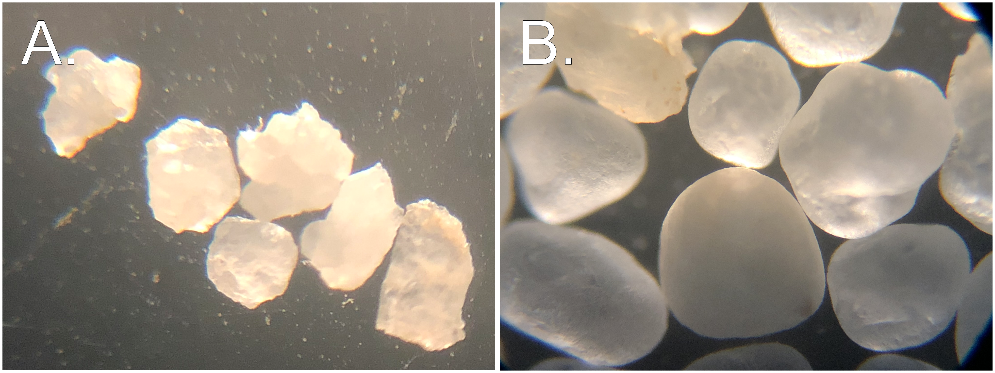

Figure 2: **A.** Angular sand used for Experiments 1 and 2. **B.** Round sand used for Experiment 2.

The chosen size classes correspond to particle diameters used in the United States Golf Association method for putting green construction (USGA, 2018). This specification is familiar to sports field managers and is often referenced when comparing infield mixes. Table ?? shows the range of the 6 total size bins. Note that these size classes are identical to those in the USDA Soil Taxonomy scheme, with the exceptions of fine and very fine sand. The USGA uses 0.15 mm (#100 sieve) as the relevant boundary, while the USDA uses 0.100 mm (#140 sieve) (Soil Survey Staff - NRCS/USDA, 1999; USGA, 2018).

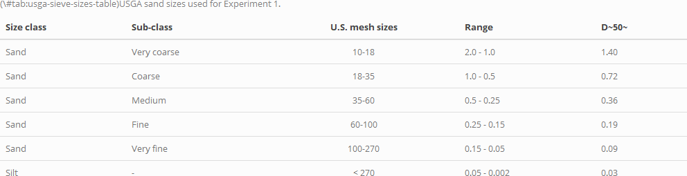

To verify the cleanliness of each coarse fraction, a complete particle size analysis was performed on each material. Figure 3 shows the samples were highly uniform, although each contained small traces of particles above and below its primary size fraction. D50 values were determined graphically from Figure 3.

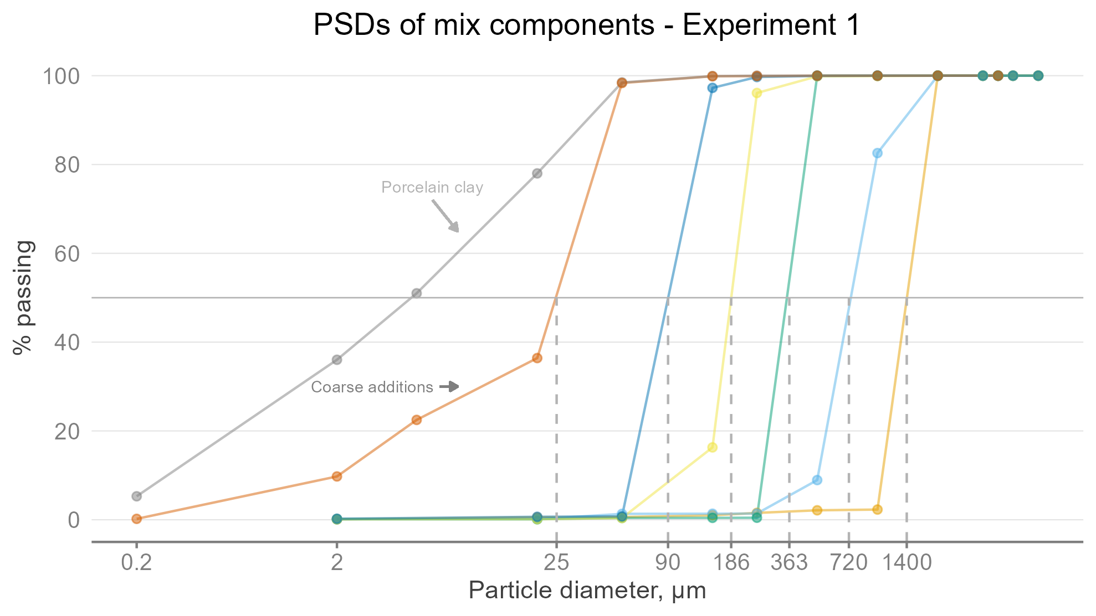

Figure 3: Particle size distributions of the 6 coarse fractions in Experiment 1. Dashed grey lines indicate D50 for a given size fraction.

The 5 sand sizes and the silt were mixed with a kaolinitic clay purchased from a ceramic supplier. The materials were combined to yield mixtures having 0, 20, 40, 60, 70, 75, and 80 % sand (or silt) by dry mass.

## Experiment 2 mixture components

Experiment 2 was an extension of Experiment 1. A highly rounded quartz sand (Figure 2 B) was mixed with the same kaolin clay . This sand was exclusively 1.0-0.5 mm sieve diameter. The sand percentages by mass were identical to those in Experiment 1 (0, 20, 40, 60, 70, 75, and 80). These mixtures were compared with those having the equivalent sand size and sand % for the angular sand/kaolin mixes in Experiment 1.

## Experiment 3 mixture components

The goal of Experiment 3 was to test the effect of sand uniformity for two sands having the same D50 and chiefly composed of particles >425 μm. Uniformity is commonly defined in terms of the Coefficient of Uniformity (Cu):

The two sands in Experiment 3 were produced from a single washed concrete sand having a wide particle size distribution. The material was repeatedly sieved to remove all particles >1 mm and <0.25 mm. The remaining fraction was riffled into two aliquots. The first half remained untouched and was termed the “low-Cu sand.” The second half had some of the “overs” and “unders” from the original concrete sand returned in order to create a wider PSD. This second material was termed the “high-Cu sand.” Figure 4 shows the particle size distributions of the low-Cu and high-Cu sands. These sands meet the criteria of having nearly identical D50 values (0.42 mm and 0.49 mm) but different Cu values (1.9 vs. 3.9).

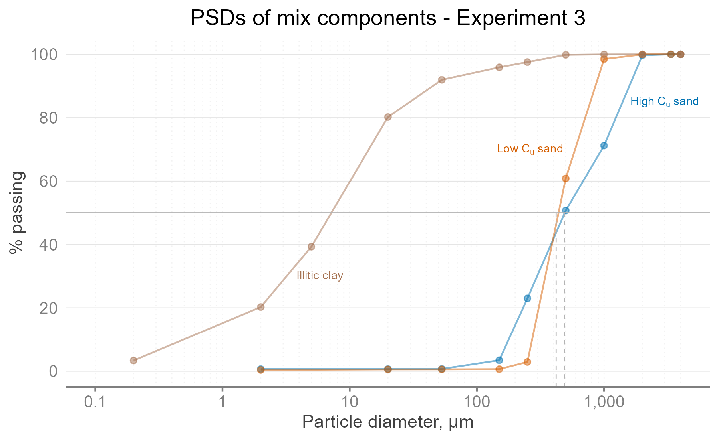

Figure 4: Particle size distributions for the two sands and one clay used in Experiment 3. Dashed grey lines indicate D~~50~~ for each sand.

X-ray diffraction showed that the mineralogy of the clay material in Experiment 3 was predominantly illite and mixed-layer illite/smectite (I/S). Its PL was 18 and its LL was 30, for a PI of 12. The clay soil was air-dried and pulverized to pass a 0.25 mm screen.

## Component characterization

Particle size analyses were performed on both clays and all coarse additions according to Gee and Or (2002). Semi-quantitative X-ray diffraction data were obtained on oriented specimen mounts prepared with a suction apparatus (Moore and Reynolds, 1997).

m Minimum and maximum density tests were performed to characterize the particle packing obtainable from the low-Cu and high-Cu sands. The methods employed were modified versions of ASTM D4254 and F1815 (ASTM International, 2011, ref-D4254-16). In the minimum density test, the air-dry sand was gently poured through a funnel into an 11.4-cm high cylinder. The surface was leveled with a straight edge and the sample was weighed. The F1815 test was performed both at 8 % gravimetric water content (as required by the protocol) and also on air-dry sand. The air-dry test produced greater compaction for all materials, so these are the values presented. Table ?? shows the porosity values attained for each test.

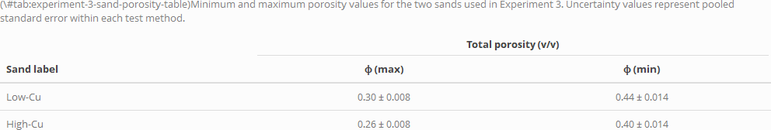

## Mixtures and Atterberg limit tests

The mixtures were blended in an air-dry condition. Corrections for the hygroscopic water content and sand content of the clay components were included when calculating the mixing ratios. Equations (3)-(4) show the formulas used to determine the air-dry masses for each component:

$$\begin{matrix}\text{Sand air-dry mass (g)} & =\frac{S_{final}-S_{clay}}{S_{sand}-S_{clay}}⋅m_{total mixture (g)}⋅(1+w_{sand}) (3) \\ & \\ \text{Clay air-dry mass (g)} & =\left[1-\left(\frac{S_{final}-S_{clay}}{S_{sand}-S_{clay}}\right)\right]⋅m_{total mixture (g)}⋅(1+w_{clay}) (4)\end{matrix}$$

where $S_{final}$ is the final mixture’s sand percentage as a decimal, $S_{sand}$ is the mass fraction of the sand/silt component > 53 μm as a decimal, $S_{clay}$ is the mass fraction of the clay component > 53 μm as a decimal[2], is the oven-dry mass of the “sand” component (as a decimal fraction of the final mixture mass), $m_{clay}$ is the oven-dry mass of the clay component (as a decimal of the final mixture mass), $m_{final}$ the total oven-dry mass of the final mixture, equal to unity, and $w$ is the gravimetric water content of a given component in decimal form.

The materials were combined in small bowls and mixed with a spatula until visually homogenous. Distilled water was added to bring the mixture approximately to its liquid limit. The liquid and plastic limit tests were performed according to ASTM D4318 (ASTM International, 2018). A minimum of four data points were collected to plot the flow curve. Three plastic limit threads were rolled and their average value was used as the representative value for the mixture.

An adhesion limit test was also performed for Experiments 1 and 2. The test was modeled after Atterberg’s original description (Atterberg, 1974). The sticky soil was gradually dried from its liquid limit using cool air from a hairdryer. As it dried, the soil was continually remolded with the operator’s fingers and periodically agitated with a galvanized steel nail. The adhesion limit was reached when the lump of soil could be pressed against the nail and then readily separated in a single piece, with no soil adhering to the metal surface. Figure 5 shows a sample above and at the adhesion limit. The sample was weighed to 0.001 g, oven-dried, and weighed again to determine its gravimetric water content $w$. Three adhesion limit determinations were made for each mixture and averaged to produce a representative value.

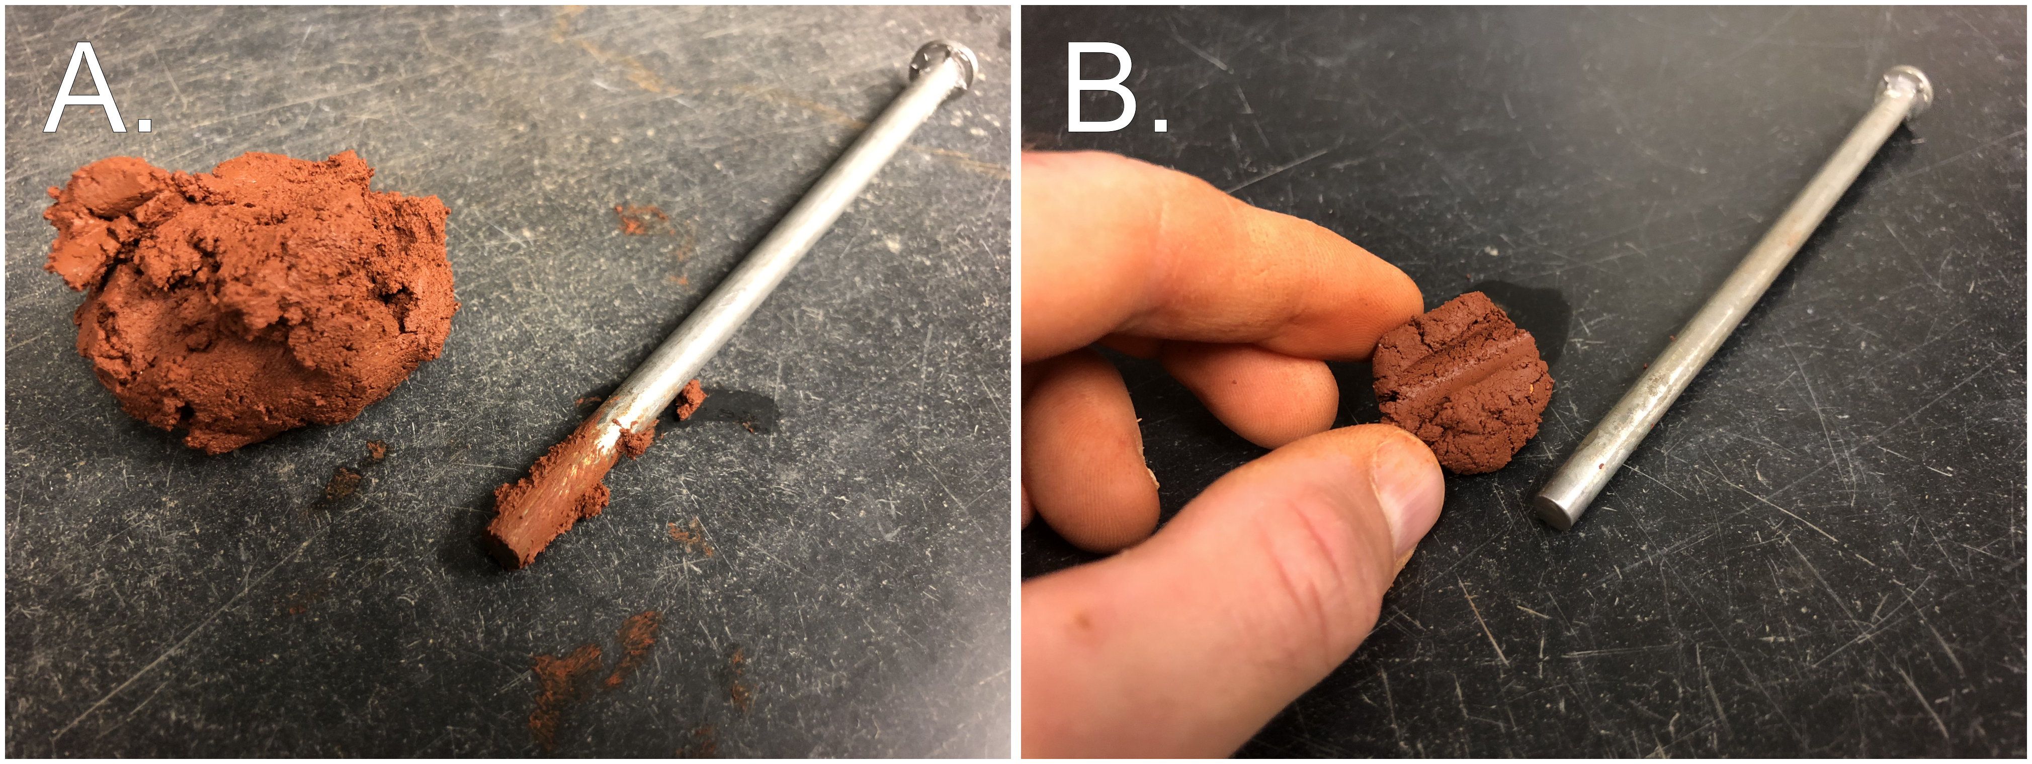

Figure 5: **A.** Soil with water content above the adhesion limit. **B.** The same sample having dried just below the adhesion limit.

# Results and discussion

## Experiment 1

The coarse fraction’s particle size notably affected both the LL and PL. Figure 6 shows the LL and PL as a function of coarse particle content, with one panel per size fraction. The dashed lines represent the water contents corresponding to the linear law of mixtures (Equation (1)).

The LL test results adhered closely to the linear law up to 20% sand or silt. Above 20% coarse addition, adherence was closer for coarser particles. The LL of mixtures containing the coarsest sand (2.0-1.0 mm) were nearly identical to those predicted by the linear law, all the way up to 75% sand. Conversely, the LL of finer materials were always higher than predicted. Silt mixtures deviated from the linear law at just 20%. Mixtures containing the finer sands began to depart from the predictions at about 40%. Above 70% sand all mixes besides those containing silt became nonplastic.

The effect of particle size was even more pronounced for the plastic limit. Mixtures containing particles > 0.25 mm still adhered closely to the linear law. Mixtures containing < 0.25 mm sand or silt had elevated plastic limits. The results began to diverge from the linear law at around 20% coarse addition, and the spread widened as more coarse particles were added.

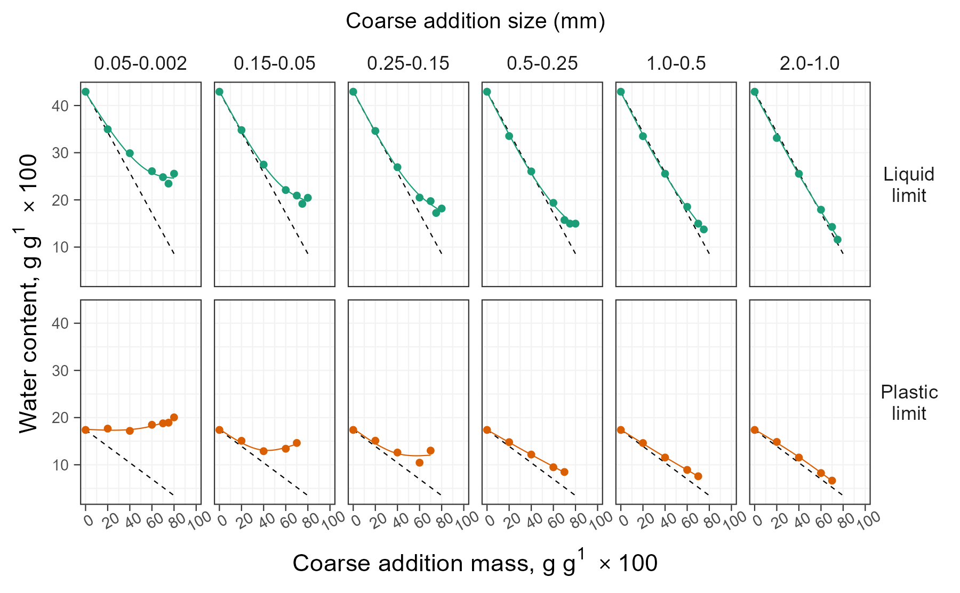

Figure 6: Liquid and plastic limits of sand-clay mixtures in Experiment 1. Dashed black lines denote the water contents predicted by the linear law of mixtures (Sivapullaiah and Sridharan, 1985).

Differences were computed between the predicted and measured LL and PL. A two-way polynomial model with interaction was fitted to these differences (Table ??). It is more instructive to consider the sand/silt particle diameter as a continuous variable, rather than via distinct classes. Therefore, both the % coarse addition and the base-10 logarithm of D50 were treated as continuous predictors. Main effects and interactions were tested using Type III Sums of Squares. As Figure 6 suggests, there was a significant interaction between % coarse addition and D50.

The physical significance of this interaction is that with increasing sand or silt, the coarse fraction’s particle size plays an increasingly important role in the mixture’s overall behavior. Figure 7 re-plots the Atterberg limits in terms of each material’s D50, with a separate plot for each % coarse addition. The slopes of the regression lines in Figure 7 represent the degree of influence imposed by the coarse grains’ sizes. When only 20% sand or silt is added, the regression slopes are shallow because all mixtures performed similarly. The lines steepen with further additions, demonstrating a larger separation between mixes having the same mass % sand or silt, but with different sizes.

To further explore this concept, the slopes (i.e., first derivative) from Figure 7 are re-plotted in Figure 8. This highlights the increasing separation between the sands with greater coarse content.

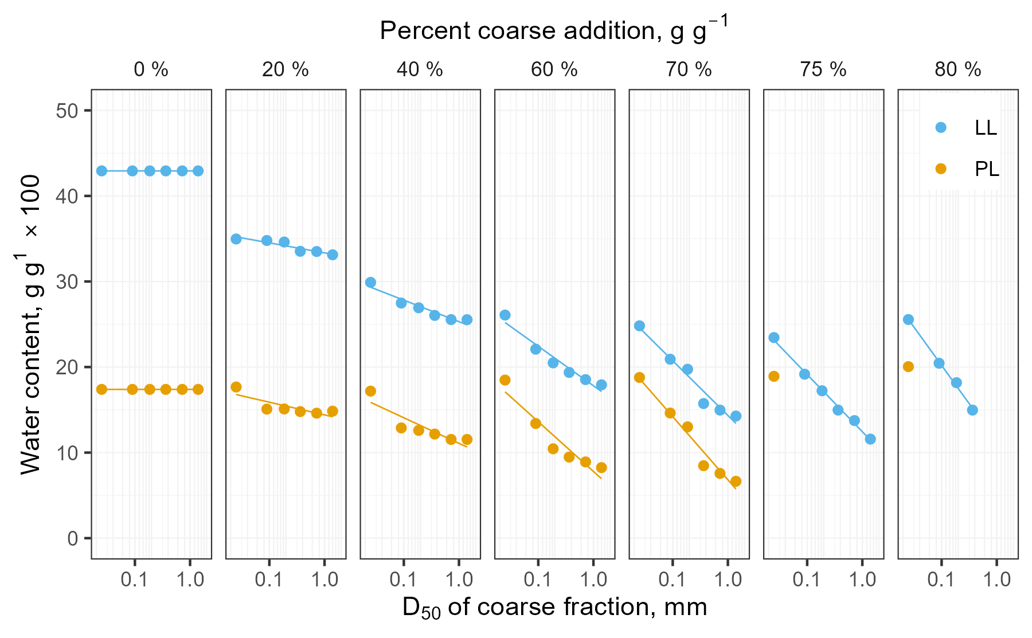

Figure 7: LL and PL as a function of both the % coarse addition and its D50.

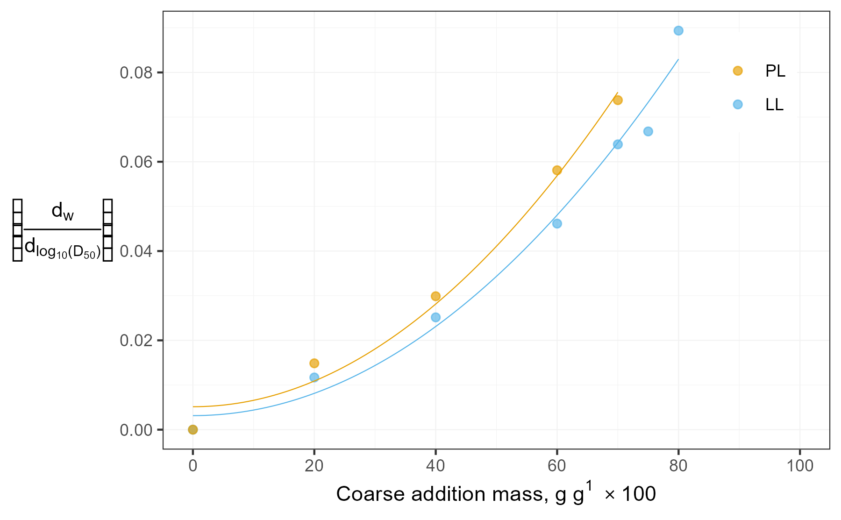

Figure 8: Absolute value of lines plotting LL or PL vs D50 for each % coarse addition.

A final point of interest is the toughness of the mixtures. Toughness may be defined in two ways: (1) qualitatively, as the shearing resistance at the plastic limit (Casagrande, 1932), or (2) quantitatively, as the total work required to deform a specimen to failure (Mamlouk and Zaniewski., 2006; Barnes, 2013). In the latter case, toughness is considered to have its maximum value $T_{max}$ at the plastic limit.

Moreno-Maroto and Alonso-Azcárate (2018) developed an empirical correlation between Atterberg limits and $T_{max}$ by re-analyzing data from Barnes (2013). Their empirical equation can be solved to predict $T_{max}$ from PI and LL:

$$T_{max} (kJ m^{-3})=\frac{\frac{PI}{LL}-0.3397}{0.0077} (5)$$

Estimated toughness values were computed from Equation (5) for all mixtures in Experiment 1. This calculation produced some negative values, which is a physical impossibility. However, the $T_{max}$ estimates are still of interest because they correspond well with qualitative assessments of toughness made while performing the tests (data not shown). Estimated values for $T_{max}$ are plotted against sand or silt content in Figure 9.

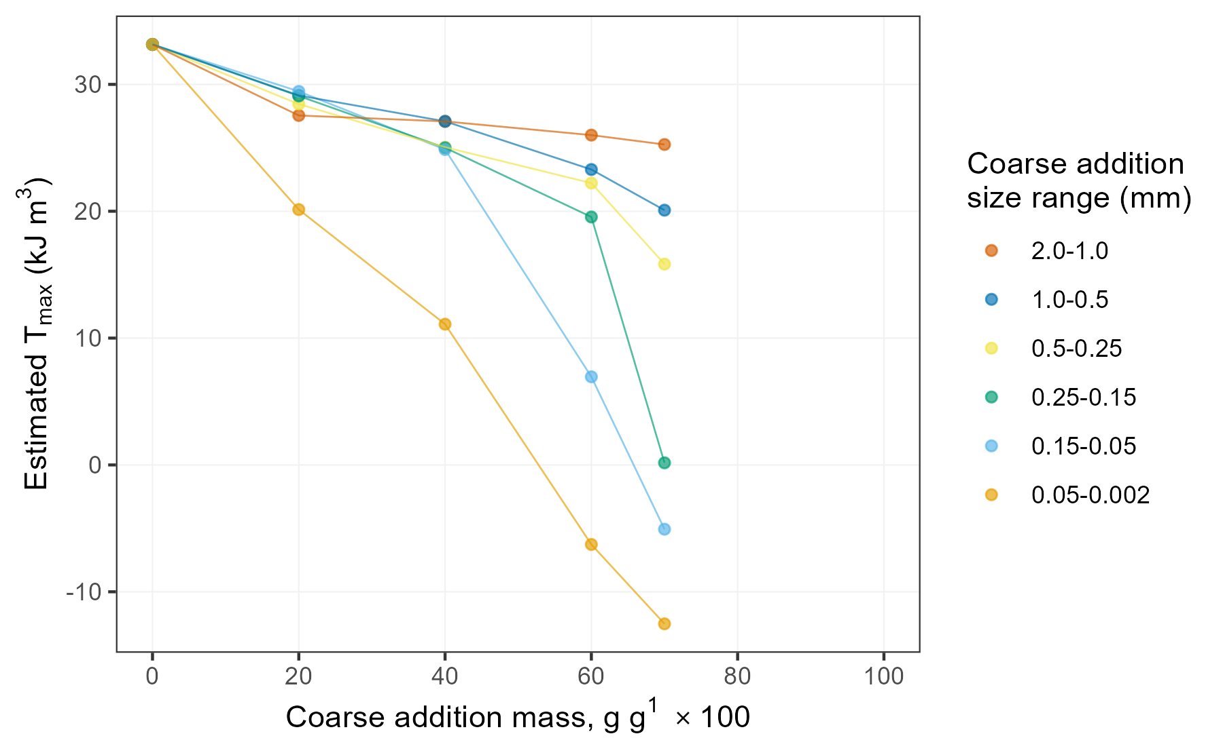

Figure 9: Estimated toughness $T_{max}$ was markedly reduced by finer sands and silt. The toughness of mixtures containing coarser sands more closely resembled that of the pure clay.

Coarse additions reduced the predicted $T_{max} of all mixtures, with the effect size being negatively related to particle diameter. For low sand content, toughness was scantly influenced, and the various size fractions performed similarly. A lone exception was the silt-sized quartz, which stood apart from the sand-size mixtures even at just 20% silt.  
The sand-size mixtures begin to separate at higher sand content, and above 50-60% sand their estimated $T_{max}$ was markedly different. This finding shows that the toughness of two sand-clay mixtures can differ, even when the sand % and PI values are similar.

A possible explanation for the mixtures’ behavior is sought in the number of “coarse” particles per unit mass. The coarsest sand used in Experiment 1 had a D50 of 1.4 mm. Assuming a specific gravity of 2.65, 1 gram of these particles comprises 260 individual grains. In contrast, the finest sand had a D50 of 0.09 mm, representing 9.9^{5} particles per gram - a factor of ~3,800. It is likely that far more particle-to-particle contacts occur in mixes containing fine sands and silt. As the soil dries, the probability of these fine particles becoming lodged in an unstable configuration would be greater. More water is required to separate the particles and allow them to slide past one another without crumbling (PL test) or slumping (LL test). This extra water results in higher water contents at both behavioral thresholds.

An alternative possibility is that the higher water contents are simply due to higher specific surface area for the smaller grains.

## Experiment 2

Experiment 2 compared the effect of particle shape for two sands of equal size. Figure 10 shows that the liquid, and plastic limits were nearly identical at sand content < 60%. At sand contents ≥ 60%, a very slight increase in both the PL and LL was observed.

A two-way ANOVA model was fitted to test the interaction effect between particle shape and % sand. Particle roundness was treated as a categorical predictor and a 2nd-order polynomial spline term was used to model the % sand. The interaction effect between particle shape and sand % was small and not statistically significant. The maximum difference between angular and round sand for any of the tests was 1.0 % water content. This finding indicates that the importance of particle angularity is rather small compared to that of particle size.

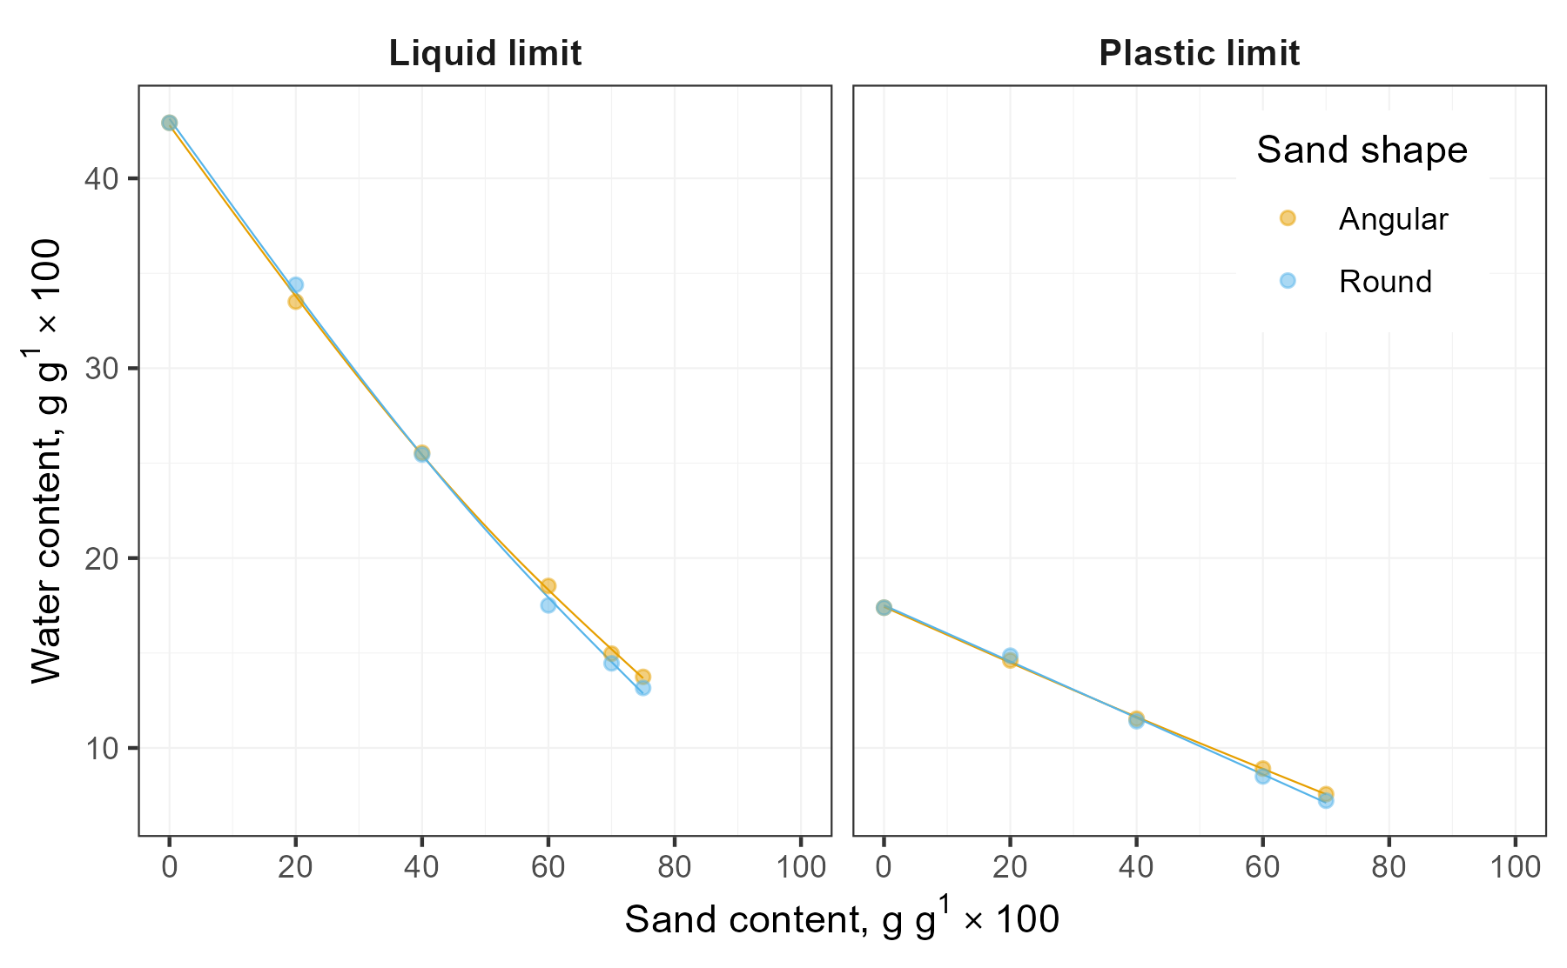

Figure 10: The effect of particle shape on both the LL and PL tests was minimal.

## Experiment 3

Figure 11 shows the LL and PL for the 21 sand contents tested in Experiment 3.

Both sands followed a linear reduction in the PL or LL up to sand content of at least 60%. This finding is in good agreement with those of Experiment 1 because both sands in Experiment 3 were relatively coarse (D50 = 0.49 and 0.42 mm). These relatively-coarse sand grains appear to have little bearing on the behavior of the clay matrix until the sand grains form a contiguous skeleton.

The low-Cu sand had higher LL and PL for nearly all mixtures. This small effect was statistically significant for the LL but not for the PL (Table ??). Though measurable, it is of little practical interest.

The mixtures became non-plastic at lower sand content when the low-Cu sand was used. Mixes containing 70, 72.5, and 75% sand had measurable plastic limits with the high-C~~u~~ sand but could not be rolled out when made with the low-Cu sand.

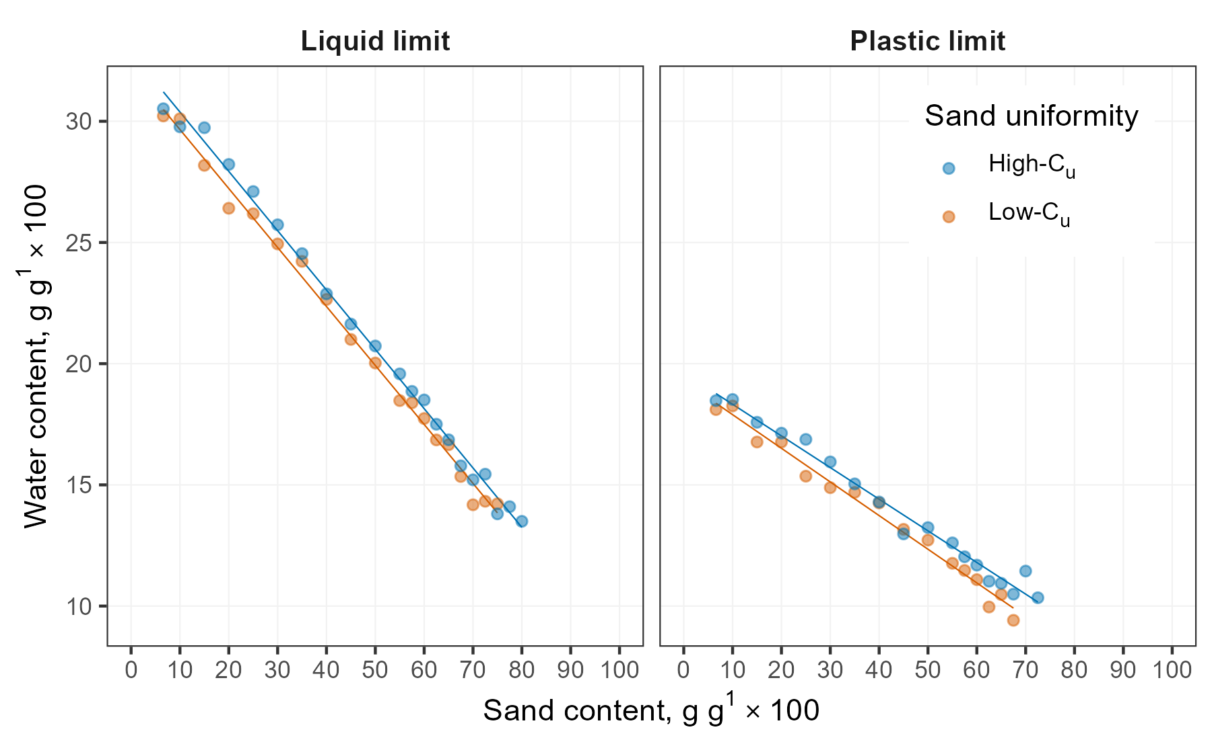

Figure 11: The high-C~~u~~ sand had higher LL and PL than the low-C~~u~~ sand at most of the tested sand contents.

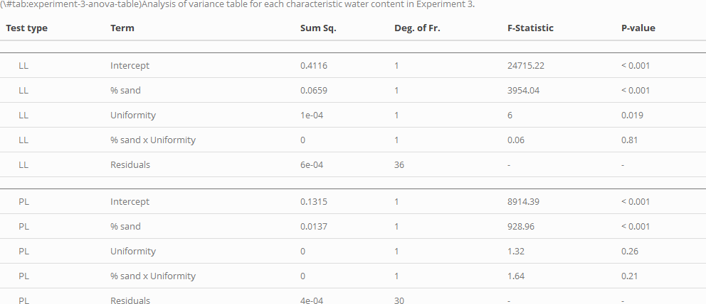

Experiment 3 shows that the effect of sand uniformity on Atterberg limits is measurable. However, it is minor compared to that of sand/silt particle size and to the plasticity of the fines.

# Conclusions

Particle size had a greater influence on mix behavior than particle shape or uniformity. Sand > 0.425 mm is prohibited by current protocols, but these particles had only a small influence on the test results. More dramatic effects occurred for the “legal” finer sands and silt. The effect of sand/silt size became increasingly important above 40% coarse addition.

Mixtures containing finer sands or silt had higher LL and PL than predicted by the linear law of mixtures. The linear law cannot apply to the PL for coarse additions ≥ 20% or to the LL for coarse additions ≥40%. PI was less affected because the LL and PL experienced similar deviations for a given mixture.

The toughness of the mixture at its plastic limit is also affected by sand/silt particle size. Mixes containing coarser sands had higher estimated $T_{max}$ at their plastic limits. This effect probably can be explained by fewer contacts between coarse particles, permitting the clay matrix to experience a more extensive drydown before crumbling. The lower water content allowed the clay matrix to stiffen without losing its plasticity. If higher toughness is a desired mixture property of the mixture, it is suggested to use the coarsest sand possible.

The results of this study demonstrate that the wet-sieving protocol may be omitted when testing the Atterberg limits of infield mixes. The larger particles do not produce confounding effects but rather change the test results less than “legal” sand and silt particles. Performing Atterberg limit tests on infield mixes without removing particles 0.425-2.0 mm would reduce processing time and yield more meaningful analyses.

# References

AASHTO. 2020. AASHTO T 89-13, Determining the Liquid Limit of Soils.

ASTM International. 2011. F1815-11 Standard Test Methods for Saturated Hydraulic Conductivity , Water Retention , Porosity , and Bulk Density of Athletic Field Rootzones. : 1–6. doi: [10.1520/F1815-11.2](https://doi.org/10.1520/F1815-11.2).

ASTM International. 2018. D4318-17, Standard Test Methods for Liquid Limit, Plastic Limit, and Plasticity Index of Soils. : 20. doi: [10.1520/D4318-17E01.](https://doi.org/10.1520/D4318-17E01.)

ASTM International. D4254-16, Test Methods for Minimum Index Density and Unit Weight of Soils and Calculation of Relative Density. ASTM International.

Atterberg, A. 1911. Die Plastizität der Tone. Intern mitt. boden: 4–37.

Atterberg, Albert. 1974. Plasticity of clays. Cold Regions Research Lab, Hanover, NJ.

Barnes, G.E. 2013. The Plastic Limit and Workability of Soils. <https://www.escholar.manchester.ac.uk/api/datastream?publicationPid=uk-ac-man-scw:212752&datastreamId=FULL-TEXT.PDF>.

Casagrande, A. 1932. Research on the Atterberg limits of soils. Public Roads 13(8): 121–136.

Casagrande, A. 1947. Classification and identification of soils. Transactions of the American Society of Civil Engineers 113: 901–991.

Dumbleton, M.J., and G. West. 1966. The influence of the coarse fraction on the plastic properties of clay soils- RRL Report No. 36. Road Research Laboratory, Crowthorne, Berkshire.

Gee, G.W., and D. Or. 2002. Particle-size analysis. In: Dane, J.H. and Topp, C.G., editors, Methods of Soil Analysis: Part 4 Physical Methods. Soil Science Society of America, Madison, WI. p. 255–293

Holtz, R.D., W.D. Kovacs, and T.C. Sheahan. 2010. An Introduction to Geotechnical Engineering. Pearson, New York, NY.

Lade, P.V., C.D. Liggio Jr., and J.A. Yamamuro. 1998. Effects of Particle Shapes and Sizes on the Minimum Void Ratios of Sand. Geotechnical Testing Journal 21(4): 336–347.

Mamlouk, M.S., and J.P. Zaniewski. 2006. Materials for civil and construction engineers. Prentice Hall, Upper Saddle River, NJ.

McBride, R.A. 2002. Atterberg Limits. In: Dane, J.H. and Topp, C.G., editors, Methods of Soil Analysis: Part 4 Physical Methods. Soil Science Society of America, Madison, WI. p. 389–398

Moore, D.M., and R.C. Reynolds. 1997. X-Ray Diffraction and the Identification and Analysis of Clay Minerals. 2nd ed. Oxford University Press.

Moreno-Maroto, J.M., and J. Alonso-Azcárate. 2018. What is clay? A new definition of “clay” based on plasticity and its impact on the most widespread soil classification systems. Applied Clay Science 161: 57–63. doi: [10.1016/j.clay.2018.04.011](https://doi.org/10.1016/j.clay.2018.04.011).

Rehman, H.U., N. Pouladi, M. Pulido-Moncada, and E. Arthur. 2020. Repeatability and agreement between methods for determining the Atterberg limits of fine-grained soils. Soil Science Society of America Journal 84(1): 21–30. doi: [10.1002/saj2.20001](https://doi.org/10.1002/saj2.20001).

Schroder, E. 2012. Setting a realistic standard for infield mixes: Opinions from the experts. SportsTurf: 8–16. <https://sportsturfonline.com/2012/03/14/setting-a-realistic-standard-for-infield-mixes-opinions-from-the-experts/4637/>.

Sivapullaiah, P.V., and A. Sridharan. 1985. Liquid Limit of Soil Mixtures. Geotechnical Testing Journal 8(3): 111–116. doi: [10.1520/gtj10521j](https://doi.org/10.1520/gtj10521j).

Soil Survey Staff - NRCS/USDA. 1999. Soil: taxonomy. United States Department of Agriculture, Washington, D.C.

Terzaghi, K. 1925. Principles of Soil Mechanics: II- Compressive Strength of Clay. Eng. News Record 95(19): 796–800.

USGA. 2018. Unites States Golf Association recommendations for a method of putting green construction.

Worrall, W.E. 1986. Clays and ceramic raw materials. Elsevier Applied Science Publishers, New York, NY.

1. The AC ultimately became the popular Unified Soil Classification System (USCS)
2. Note that because $S_{sand}$ and $S_{clay}$ are referenced to different soils,